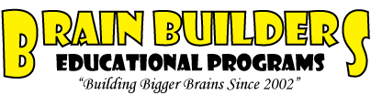
www.BrainBuildersEd.org
info@brainbuildersed.org
714-360-1101

Engineering with Lego Blocks: Animal Locomotion

DAY 6

Review:
- Previous lessons
- Ask question to have students earn Engineering Bucks
  - Sample questions: What does the battery represent? – The Heart
  - What does the Gearbox represent? – Main skeleton
  - What does the switch represent? – Brain
  - What does the Motor represent? – Muscles
  - Whats an example of a hinge joint? – Elbow or knee

Lesson – Friction & Traction

What is friction? – Friction is caused when to objects rub against each other. Like the wheels of a car and the road or your feet and the ground. Even the wind against your body causes friction when you run.

What is traction? – Traction is caused by friction, and usually applied in race cars or when you are running. To increase traction, friction is also increased. More traction usually means things are more “sticky”, less traction and things are more “slippery”.

Traction can be increased by-
- Increasing weight of the moving object
- Increasing the “stickiness” of the feet
- Increasing how much of the “stickiness” is in contact with the ground

Start the final day Challenge: Have the students work in pairs. This will be a 2 day event.

- Make any walking animal that can make it up the slippery slope (students can use rubber bands to make their animal’s feet more sticky.
- Increase the slope when they complete one incline.

Awards will be given for the animal that can make it up the steepest slope and for the most creative animal.

Pass out boxes to students sitting properly first.

